Abstract—When considering the question of which counter to choose to complete the checkout process most quickly in a large supermarket, I have devised a priority queue that takes two priorities into account. Furthermore, I implemented the designed priority queue using linked lists, heaps, and binary search trees, analyzing the time complexity of each. Additionally, I implemented these three algorithms in C, drew graphs using Python, and analyzed the experimental results. Through this, it is expected that the checkout speed in large supermarkets can be optimized. Moreover, the application of these algorithms is not limited to supermarkets but can also be extended to areas such as transportation and logistics management, financial transaction processing, and healthcare queue management, efficiently responding to requests in various fields.

Optimizing Checkout Efficiency: A Multi-Priority Queue Approach for Large Supermarkets and Beyond
Minseok Kang
Dept. of Software, Sungkyunkwan University, Suwon, South Korea
min.seok@g.skku.edu

Introduction
In the dynamic environment of a large supermarket, the efficiency of the checkout process plays a crucial role in providing a satisfactory shopping experience for customers. Contemplating the challenge of determining the optimal counter for swift transactions, I have proposed a novel solution employing a priority queue that accounts for two distinct priorities. This innovative approach aims to streamline the checkout experience, considering factors that could significantly impact processing speed.

To implement and assess the effectiveness of this solution, I delved into the realms of data structures and algorithms, utilizing linked lists, heaps, and binary search trees. The subsequent analysis involved a comprehensive examination of the time complexities associated with each algorithm. Going beyond theoretical considerations, practical implementations were realized in the C programming language. The performance of these algorithms was further scrutinized through graphical representations using Python, culminating in a detailed analysis of experimental results.

While the primary focus lies in optimizing checkout processes within large supermarkets, the versatility of this proposed solution extends beyond retail. It holds the potential to revolutionize various domains, including transportation and logistics management, financial transaction processing, and healthcare queue management. This research endeavors to pave the way for efficient and responsive solutions tailored to diverse scenarios, contributing to the broader landscape of algorithmic applications.

Design and Implementation

System Design
To optimize the checkout process in a large supermarket, I have separated the calculation process into two distinct phases: the entry process and the exit process. During the entry phase, the objective is to choose the counter with the fastest calculation time, i.e., the smallest completion time. In case of ties in completion times, the counter with the smallest number should be selected. Subsequently, during the exit process, calculations with the smallest completion times need to be extracted first. If completion times are identical, the counter with the largest number should be chosen.

The data structure involves information for n customers, including customer numbers and the time required for checkout. Assuming a quantity of 2500 customers, derived from dividing the maximum vehicle visits in June 2023 (710,000)_{[1]} by 30, five datasets have been created for experimentation. This data needs to be inserted for each customer arrival, and the sequence of departures must be determined for sorting.

Implementation in Detail
I have constructed both a counter priority queue and a customer priority queue. Given that the number of customers far exceeds the number of counters, the time complexity will be determined by the priority of customers. Therefore, I implemented the counter priority queue using a heap, and to compare three data structures based on customer priority queue, I created three solutions. Although the logic in each solution is identical, as seen in Figure 1, I distinguished the modules used in the code into customer_array, customer_bst, and customer_heap for implementation purposes.

The logic is as follows: when a customer arrives, dequeue the counter priority queue, add the calculation time of the customer to the time member variable of the corresponding counter object, and enqueue it. Then, enqueue the new customer information into the customer priority queue. Once all entries are completed, sort by dequeuing from the customer priority queue until its size becomes 0.

Each customer priority queue module includes initialization, insertion, and deletion functions. I referred to the implementation methods provided in the lecture notes, with the distinction that functions considering two priorities were added due to the need for dual prioritization.

To generate data, I used the random function in Python to allocate processing times. I assigned seed values from 1 to 5 to induce consistent experimental results. The time measurement was conducted using the time.h header file in C. For recording and graph plotting, I utilized Python's subprocess and matplotlib libraries.

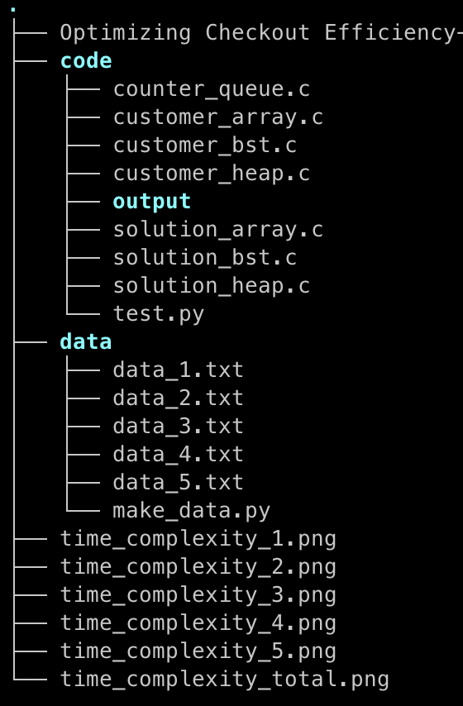
Fig. 1. Folder structure of project
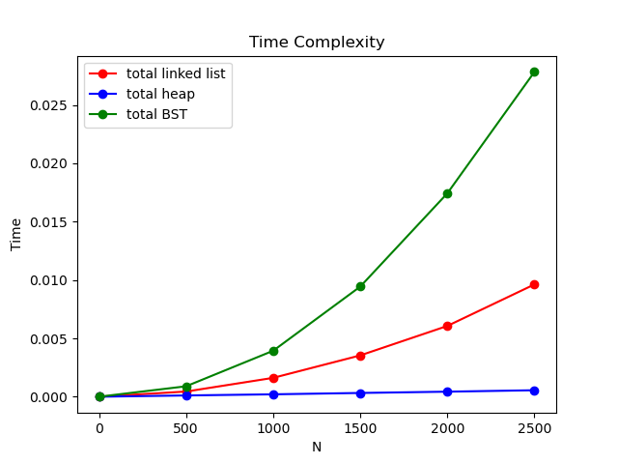
Fig. 2. Graph of experiment result

Performance Evaluation

Experiment Setup
In this experiment, I conducted local testing on the Apple 2022 MacBook Air with M2 chip. The M2 CPU operates at a clock speed of 3.49 GHz, and the RAM capacity is 8GB. The operating system used for the experiment is macOS. The experimental setup involves inserting data for all customers and subsequently performing dequeue operations to achieve sorting. This process entails conducting insertions and deletions for each of the n customers.

Analysis
Since priority queues were implemented using queues, linked lists, and BSTs, the time complexity for insertion and deletion for each is summarized in Table 1. Figure 2 illustrates the time taken to compute five datasets, each containing 2500 data points, with the results averaged. In this graph, it is evident that both linked lists and BSTs theoretically have a time complexity of O(n^2). However, the graph shows that BSTs take significantly more time. This is due to the fact that while a balanced BST ideally has an average time complexity of log n for insertion and deletion, the skewed structure of the data leads to an approximation of the worst-case scenario of O(n) for each operation, resulting in the observed issue. In contrast, when implemented with a heap, the time complexity is n log n, significantly outperforming the other two algorithms in terms of time efficiency.

TABLE I
time complexity of structure
structure | Insert | Delete
Linked List | O(n) | O(1)
Binary Search Tree | O(log(n)) | O(log(n))
Heap | O(log(n)) | O(log(n))

Conclusions
In this study, a new priority queue solution was proposed to optimize the checkout process in large supermarkets. This solution was designed to enhance the speed of customer transactions by considering two different priorities and implementing counters and customers as priority queues.
The actual implementation involved constructing priority queues for counters and customers using linked lists, heaps, and binary search trees. The experimental results indicated a significantly higher performance of the heap structure compared to the other two algorithms. This can be interpreted as the heap having a time complexity of O(n log n), providing superior efficiency.
However, for linked lists and binary search trees, the performance varied significantly depending on the distribution of data. Particularly, binary search trees exhibited worst-case performance when data was skewed to one side, emphasizing the importance of choosing an appropriate data structure based on the characteristics of the data.
The findings of this study can be applied not only to large supermarkets but also to various fields such as transportation, logistics, finance, and healthcare, providing a foundational basis for efficient service delivery. The approach to improving customer service, along with the proper selection of priority queues, has yielded valuable research results applicable across diverse industries.
Reference
- “방문객 줄어든 대형마트…먹거리 가격 인하로 반등 모색하나?”.”세계일보”. https://m.segye.com/view/20230704514552

